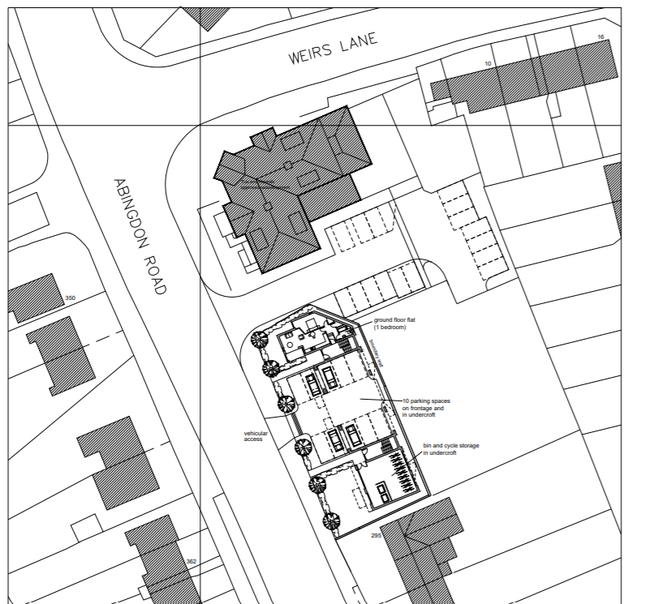
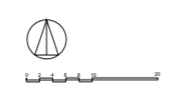
Appendix 1 - 19/02578/OUT - Site Plan

